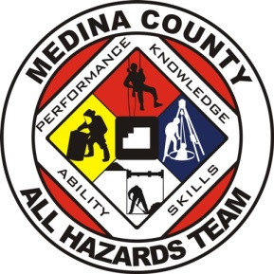 | Medina County  All Hazards Team  Application Guidelines and Forms  2025
Thank you for your interest in the Medina County All Hazards Team! The Team consists of representatives from law enforcement agencies, fire departments, EMS agencies, EMA, the Prosecutor’s Office, and the Coroner’s Office. The Team covers seven disciplines. Administrative and operational oversight is provided by the EMA Executive Committee, through the Medina County All Hazards Committee (AHAC).
This application packet includes the following items:
- Welcome letter with completion and submission guidelines.
- Medina County All Hazards Team Membership SOG
- Medina County All Hazards Team Discipline SOG
- Medina County All Hazards Team Application (fillable Word document).
Step 1: Please review this welcome letter with completion and submission guidelines.
Step 2: Read the Medina County All Hazards Team Membership SOG. You will be asked on the application form, that you have read, understand, and agree to abide by the SOG.
Step 3: Read the Medina County All-Hazards Team Discipline SOG. You will be asked on the application form, that you have read, understand, and agree to abide by the SOG.
Step 4: Save the application form to your electronic device. Complete it as a fillable document. You must ensure that all the fields are completed. Application forms will not be accepted with missing information.
Step 5: Print and sign the application form.
Step 6: Have your Chief/Supervisor sign the application form.
Step 7: Scan the application form, along with a copy of your ODPS certification (if applicable), LE Commission (if applicable) and a copy of your driver’s license.
Step 8: Email the completed packet to cstiver@medinacountyema.org
When your application is received and approved, you will be added to Aladtec (scheduling and records management system) and Active911 (paging system). You will receive notifications allowing you access to Aladtec along with guidance on signing up for training. Further guidance will be provided by your Team Lead during your initial training.
Should you have any questions, please contact me at cstiver@medinacountyema.org, or call me directly at 330-241-3983.
Respectfully
Chuck Stiver – Coordinator
Medina County All Hazards Team

