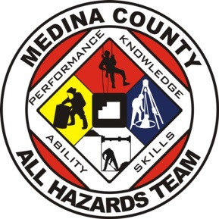 | Medina County  All Hazards Team  Application  2024

Date: Click or tap here to enter text.
Name: Click or tap here to enter text.
Date of Birth: Click or tap to enter a date.
Last 4 digits of SSN: Click or tap here to enter text.
Sponsoring Department: Click or tap here to enter text.
Home Address: Click or tap here to enter text.
City: Click or tap here to enter text.
Zip Code: Click or tap here to enter text.
Cell Phone Number: Click or tap here to enter text.
Cell Phone Carrier: Click or tap here to enter text.
Cell phone operating system: ☐Apple iOS ☐Android
Active 911 Device Code: Click or tap here to enter text.
Email Address: Click or tap here to enter text.
ODPS Certification # Click or tap here to enter text.
Driver’s License # Click or tap here to enter text.
Driver’s License Expiration Date: Click or tap to enter a date.
Disciplines You Will Participate In:
☐ Hazmat
☐ Rope/Confined Space
☐ Trench
☐ Structural Collapse
☐ Water
☐ Fire Investigation Unit
Current Certification Levels:
Hazmat
☐ Awareness ☐ Operations ☐ Technician
Rope
☐ Awareness ☐ Operations ☐ Technician
Confined Space
☐ Operations ☐ Technician
Trench
☐ Competent Person ☐ Operations ☐ Technician
Structural Collapse
☐ Awareness ☐ Operations ☐ Technician
Water
☐ Water Rescue Awareness ☐ Swiftwater Operations ☐ Swiftwater Technician ☐ Ice Rescue Technician
☐ Public Safety Diver
Fire Investigation
☐ Evidence Collection Technician ☐ Fire Investigation Technician ☐ Certified Fire Investigator
☐ Knowledge 1 Fire Investigation

☐ Applicant has read and understands the Medina County All Hazards Team Membership SOG 22-001 and agrees to abide by these operational guidelines.

Applicant’s Signature

Sponsoring Chief’s/Supervisor’s Signature
☐ I have reviewed the above application. As the sponsoring agency, I understand our local responsibilities related to scheduling, pay, and workers compensation coverage, related to the applicant’s participation during both training and calls. Therefore, the applicant has my permission to function as a member of the Medina County All Hazards Team.

